Psy 101 Research Project
Student’s Name
Institutional Affiliation

Psy 101 Research Project
Psychology in my Life and Career
A
I was once involved in a robbery incident that greatly affected me psychologically; an issue that I have been dealing with ever since that day. I was in the company of my friend coming from a local sports bar at around 11:00PM after watching a football match between our favorite teams. A gang of 5 armed robbers accosted us and stole all the money and possessions we had at gunpoint in addition to stabbing my friend in arm for failing to cooperate with their demands. The incident scarred me both emotionally and psychologically in that I stopped feeling safe even in my house. I could not walk around my neighborhood after dark and up-to this day I do not trust people that I am not accustomed to or familiar with. The anxiety I felt started affecting my performance at work and that when I decided to talk to a friend who worked in the security sector, who gave me reassurances that I was safe. Talking with my friend about the incident helped me cope with my fears and allowed me to get back to my normal life.
B
Forensic Psychology
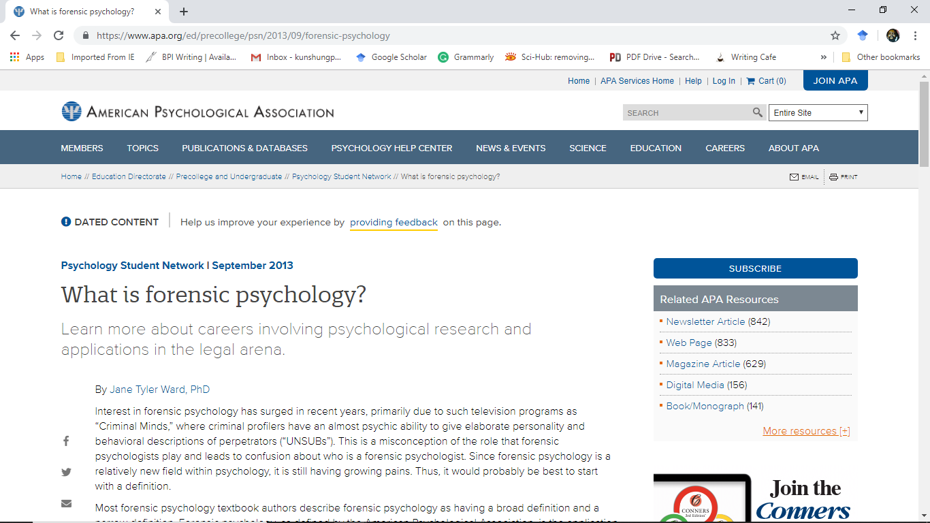
Health Psychology
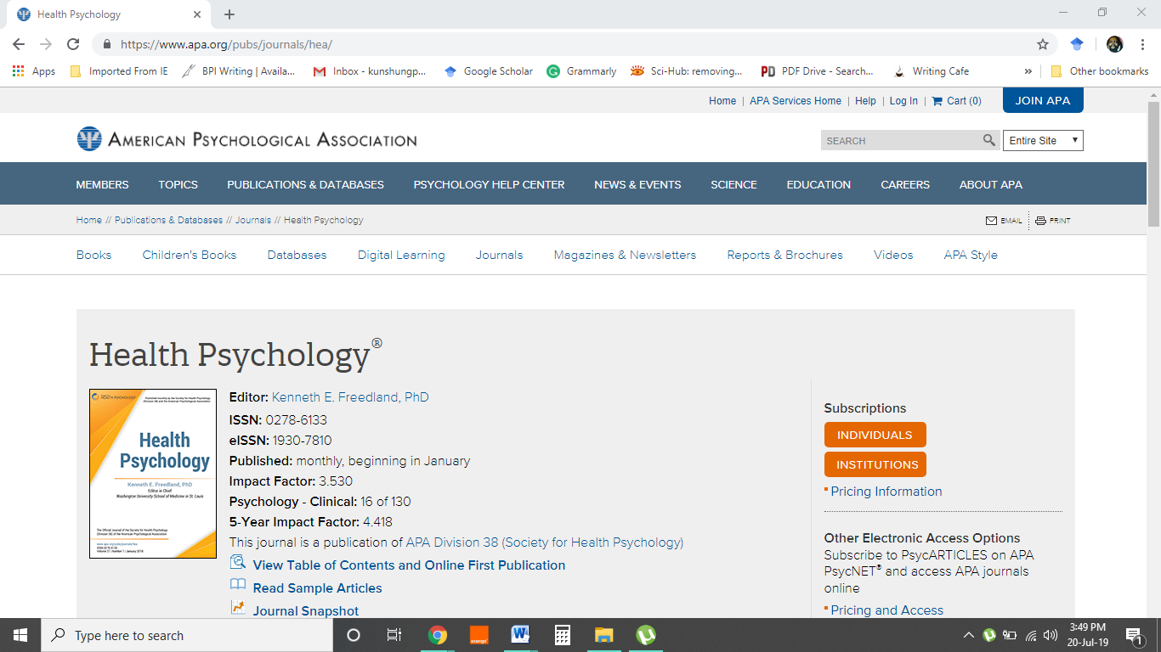
Organizational Psychology

C
I work in the research sector by profession and solving or finding answers to various issues and challenges is my forte. However, I usually encounter problems especially in decision making whereby I struggle with identifying the best possible solution from a myriad of choices. The use of heuristics a psychological approach in solving problems has helped me a narrow down my options in numerous occasions (Kalat, 2016). As a researcher, I some encounter situations where I have to work with a limited number of options to choose from; in such circumstances I use trial-and-error to rule out solutions that do not meet the required criterion or established needs.
D
Research into the prevalence of psychology in Saudi Arabia reveals that more than 50% of all graduates are involved or practice meaningful careers in psychology as illustrated in Figure1 below.
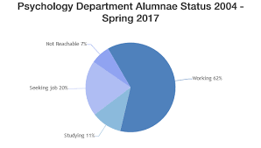
Fig1. Prevalence of Psychology as a Profession in Saudi Arabia Retrieved from: https://www.effatuniversity.edu.sa/English/Academics/Undergraduate/CoSH/Pages/psy.aspx
Further inquiry was carried out into how education supports or facilitates the development of psychology not only as an academic course, but also as a viable economic vocation. The investigations revealed that interest into the field has been mounting over the past few years as illustrated by Figure2 below.
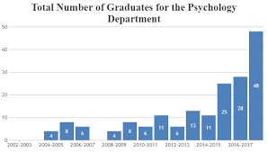
Fig2: Incidence of Psychology in Higher Education in Saudi Arabia Retrieved from: https://www.effatuniversity.edu.sa/English/Academics/Undergraduate/CoSH/Pages/psy.aspx
The information displayed by the infographics above reveals that the field of psychology is growing in the country. The most popular careers in psychology include addiction and school psychology jobs. This observation can be used to conclude that there is an increasing incidence of substance and drug abuse; an aspect that can also be related to high demand for school counsellors (Lindsay & Norman, 2013). High rates of delinquency in society can be used as indicators of the potential for substance and drug abuse amongst its population.
E
The field of psychology I would wish to join is forensic psychology that involves the psychological assessment of people experiencing difficulties integrating into society or breaking away from social norms and the law (Kalat, 2016). I have always desired working in the criminal justice system and by being a forensic psychologist I could be a valuable addition to an investigative team.

References
Kalat, J. W. (2016). Introduction to psychology. Nelson Education.
Lindsay, P. H., & Norman, D. A. (2013). Human information processing: An introduction to psychology. Academic press.

